Creating Spring Boot Projects with Eclipse and Maven
There are three options to create Spring Boot Projects with Eclipse and Maven
- Spring Initializr - https://start.spring.io
- Use STS or STS Eclipse Plugin and Create a Spring Boot Maven Project directly from Eclipse
- Manually Create a Maven Project and add Spring Boot Starter Dependencies.
We will use a Spring Boot Starter Web as an example.
Option 1 - Bootstrapping Spring Boot Project with Spring Initializr
Creating a Web application with Spring Initializr is a cake walk. We will use Spring Web MVC as our web framework.
Spring Initializr http://start.spring.io/ is great tool to bootstrap your Spring Boot projects.
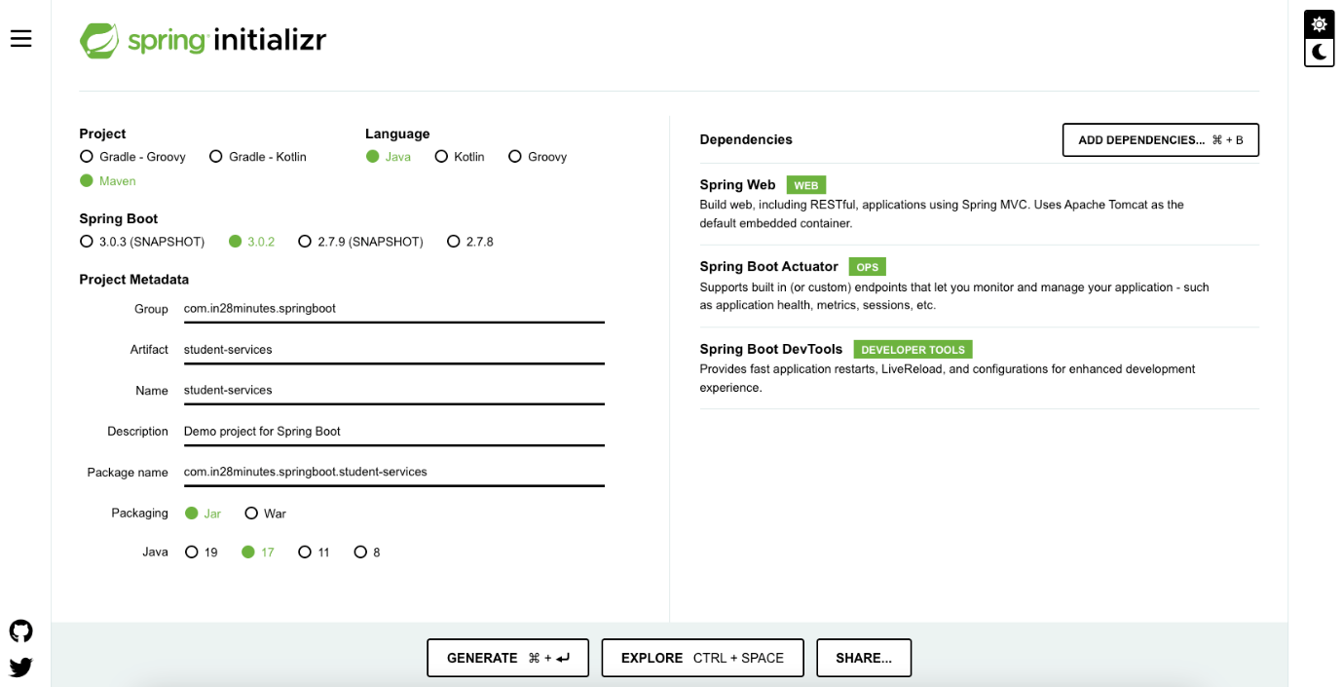
As shown in the image above, following steps have to be done
- Launch Spring Initializr and choose the following
  - Choose com.in28minutes.springboot as Group
  - Choose student-services as Artifact
  - Choose following dependencies
    - Web
    - Actuator
    - DevTools
- Click Generate Project.
This would download a zip file to your local machine.
Unzip the zip file and extract to a folder.
In Eclipse, Click File -> Import -> Existing Maven Project as shown below.
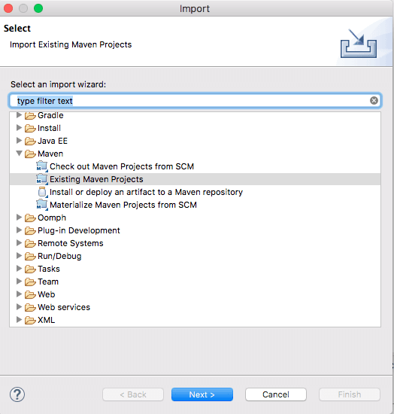
Navigate or type in the path of the folder where you extracted the zip file to in the next screen.
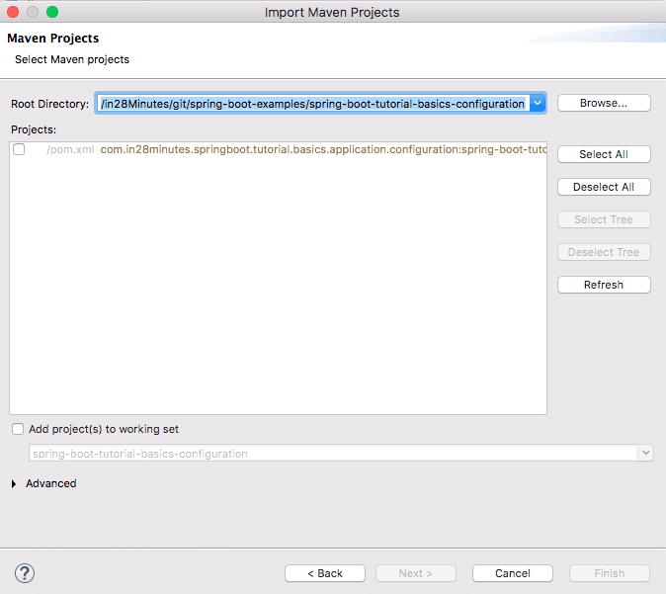
Once you click Finish, Maven would take some time to download all the dependencies and initialize the project.
That’s it. Your first Spring Project is Ready.

………………………………………………………………………………….
Spring Boot is built on the top of the spring and contains all the features of spring. And is becoming a favourite of developers these days because of its rapid production-ready environment which enables the developers to directly focus on the logic instead of struggling with the configuration and setup.
Spring Boot is a microservice-based framework and making a production-ready application in it takes very little time. Following are some of the features of Spring Boot:
- It allows avoiding heavy configuration of XML which is present in spring
- It provides easy maintenance and creation of REST endpoints
- It includes embedded Tomcat-server
- Deployment is very easy, war and jar files can be easily deployed in the tomcat server
Lets create a simple “Hello World” Spring Boot application and run it inside our Eclipse IDE.
Procedure
- Create and set up Spring Boot Project in IDE.
- Add the spring-web dependency in your pom.xml file.
- Create one package and name the package as “controller in the project.
- Run the Spring Boot application.
Step 1: Create and Setup Spring Boot Project in Eclipse IDE
Step 2: Add the spring-web dependency in your pom.xml file. Go to the pom.xml file inside your project and add the following spring-web dependency.

- pom.xml
<dependency>
<groupId>org.springframework.boot</groupId>
<artifactId>spring-boot-starter-web</artifactId>
</dependency>
Step 3: In your project create one package and name the package as “controller”. In the controller, the package creates a class and name it as DemoController.
Example 1A
- Java
// Java Program to Illustrate DemoController

// Importing package to code module
package com.example.demo.controller;
// Importing required classes
import org.springframework.stereotype.Controller;
import org.springframework.web.bind.annotation.RequestMapping;
import org.springframework.web.bind.annotation.ResponseBody;

// Annotation
@Controller

// Class
public class DemoController {

@RequestMapping("/hello")
@ResponseBody

// Method
public String helloWorld()
{
// Print statement in the browser
// http://localhost:8084/hello
return "Hello World!";
}
}
We have used the below annotations in our controller layer. Here in this example, the URI path is /hello.
- @Controller: This is used to specify the controller.
- @RequestMapping: This is used to map to the Spring MVC controller method.
- @ResponseBody: Used to bind the HTTP response body with a domain object in the return type.
Now, our controller is ready. Let’s run our application inside the DemoApplication.java file. There is no need to change anything inside the DemoApplication.java file.
Example 1B
- Java
// Java Program to Illustrate DemoApplication

// Importing package module to code
package com.example.demo;
// Importing required classes
import org.springframework.boot.SpringApplication;
import org.springframework.boot.autoconfigure.SpringBootApplication;

// Annotation
@SpringBootApplication
// Main class
public class DemoApplication {
// Main driver method
public static void main(String[] args)
{
SpringApplication.run(DemoApplication.class, args);
}
}
Step 4: Run the Spring Boot Application
Step 5: Right Click Project – maven install
To run the application click on the green icon

Lets learn
- How to bootstrap a simple project with Spring Initializr?
- How to use Spring Starter Eclipse Plugin to create a simple project with Spring Boot, Maven and Eclipse?
- How to create a Spring Boot Project manually step by step?
Tools you will need
- Maven 3.0+ is your build tool
- Your favorite IDE. Can use Eclipse or IntelliJ.
- JDK 17+
Introduction to Maven
Q : Why Maven?
You do not want to keep all of your libraries in your project!
You want to tell the tool that I require A, B, and C, and you want it to download the libraries and make them accessible to you.
Maven is the name. The application that you use to manage your libraries.
Whenever you require a new version of the library, simply change the version number and your project is complete!
You also don’t have to worry about which libraries your library need to function. Spring, for example, may require additional libraries like as logging, xml, and so on.
When you declare Spring as a dependency, Maven will download it.
- Spring
- And all dependencies of Spring
Isn’t that cool?
Big Picture of Maven
It is tough to define what Maven accomplishes.
Every day, Developer undertakes a variety of tasks.
- Manages Dependencies
  - Web Layer (Spring MVC)
  - Data Layer (JPA - Hibernate) etc.
- Build a jar or a war or an ear
- Run the application locally
  - Tomcat or Jetty
- Deploy to a T environment
- Add new dependencies to a project
- Run Unit Tests
- Generate Projects
- Create Eclipse or IntelliJ Workspace
Maven helps us do all these and more…
Naming a project
Dependencies are specified in your pom.xml file.
Maven would fetch the dependencies and include them in your project.
Yet, how does Maven know which dependencies to download?
You must explain it by providing specifics about the dependency.
A maven artefact may be identified by a GroupId and an ArtifactId, much way a Java class can be identified by a class name and a package name.
<groupId>com.in28minutes.learning.maven</groupId>
<artifactId>maven-in-few-steps</artifactId>
Declaring Dependencies
Dependencies are frameworks required to construct your project.
In the example below we are adding two dependencies.
<dependency>
<groupId>org.springframework.boot</groupId>
<artifactId>spring-boot-starter-web</artifactId>
</dependency>

<dependency>
<groupId>org.springframework.boot</groupId>
<artifactId>spring-boot-starter-test</artifactId>
<scope>test</scope>
</dependency>
Maven Build Life Cycle
When we execute “mvn clean install,” we finish the whole maven build life cycle.
LifeCycle construction is a series of phases.
- Validate
- Compile
- Test
- Package
- Integration Test
- Verify
- Install
- Deploy
Maven follows Convention over Configuration.
Pre defined folder structure
- Source Code
  - ${basedir}/src/main/java
  - ${basedir}/src/main/resources
- Test Code
  - ${basedir}/src/test
How does Maven Work?
All jars in the Maven Repository are indexed by artefact id and group id.
When we add a dependence to our pom.xml, maven queries the maven repository for jar dependencies, using the group id and artefact id as input.
- Maven repository stores all the versions of all dependencies. JUnit 4.2,4.3,4.4
The jar dependencies are saved on your system in the maven local repository folder. All of our projects would make use of the jars in the maven local repository.
Local Repository : a temp folder on your machine where maven stores the jar and dependency files that are downloaded from Maven Repository.
Important Maven Commands
- mvn –version -> Find the maven version
- mvn compile -> compiles source files
- mvn test-compile -> compiles test files - one thing to observe is this also compiles source files
- mvn clean -> deletes target directory
- mvn test -> run unit tests
- mvn package -> creates a jar for the project
- help:effective-settings -> Debug Maven Settings
- help:effective-pom -> Look at the complete pom after all inheritances from parent poms are resolved
- dependency:tree -> Look at all the dependencies and transitive dependencies
- dependency:sources -> Download source code for all dependencies
- –debug -> Debug flag. Can be used with all the above commands

Error starting ApplicationContext. To display the condition evaluation report re-run your application with 'debug' enabled. 2024-11-10T10:28:24.801+05:30 ERROR 6784 --- [first_spring] [ restartedMain] o.s.b.d.LoggingFailureAnalysisReporter : *************************** APPLICATION FAILED TO START *************************** Description: Web server failed to start. Port 8082 was already in use. Action: Identify and stop the process that's listening on port 8082 or configure this application to listen on another port.
This error may be encountered while running your Spring Boot application in Eclipse indicates that the application failed to start because port 8082 is already in use. Here’s how to resolve this issue:
Steps to Resolve the Port Conflict
- Identify the Process Using Port 8082:
  - You can check which process is using port 8082 by running the following command in your terminal or command prompt:
    - On Windows:
netstat -ano | findstr :8082
    - On Linux or macOS:
bash
lsof -i :8082
  - This will show you the PID (Process ID) of the process using that port.
- Stop the Process:
  - Once you have identified the PID, you can terminate it:
    - On Windows:
OPEN cmd prompt and type :
taskkill /PID <PID> /F
    - On Linux or macOS:
bash
kill -9 <PID>
- Change the Application Port (if you prefer not to stop the existing process):
  - You can configure your Spring Boot application to run on a different port by modifying the application.properties file in your resources directory. Add or change the following line:
server.port=8084
  - Replace 8084 with any other available port number.
- Run with Debug Enabled (optional):
  - To get more detailed logs that can help with debugging, you can enable debug mode when starting your application. This can be done by adding --debug to your run configuration in Eclipse or modifying your application.properties FILE:
debug=true
- Re-run Your Application:
  - After making these changes, try running your Spring Boot application again from Eclipse.
Additional Considerations
- If you frequently encounter port conflicts, consider implementing a mechanism in your development setup to automatically select available ports.
- Ensure that no other instances of your application are running, as this is a common cause of port conflicts.
- If you're using Docker or similar containerization tools, ensure that containers are properly stopped before re-running applications.
By following these steps, you should be able to resolve the port conflict and successfully start your Spring Boot application.

Spring Boot JDBC- MySQL Project
- How to use Spring Boot Started JDBC?
- How to connect a Spring Boot project to a database using Spring JDBC?
- How to write a simple repository class with all the CRUD methods?
- How to execute basic queries using Spring JDBC?
- How to create a project using Spring Boot, Spring JDBC, and MySQL?
- How to use a spring-boot-starter-jdbc starter for using JDBC with the HikariCP connection pool.
Tools and Technologies used
1. Spring boot 3+
2. Spring JDBC
3. Maven 3+
4. JDK 17
5. IDE - Eclipse or STS
6. MySQL connector and database
Development Steps
- Create a Spring Boot Application
- Maven dependencies
- Database Setup
- MySQL Database configuration
- Creating Employee Bean
- Create Employee JDBC Repository
- Run Application
1. Create a Spring Boot Application
There are many ways to create a Spring Boot application. You can refer to the below articles to create a Spring Boot application.
>> Create Spring Boot Project With Spring Initializer
>> Create Spring Boot Project in Spring Tool Suite [STS]
2. Maven Dependencies
Here is the complete pom.xml file for your reference:
<?xml version="1.0" encoding="UTF-8"?>
<project
xmlns="http://maven.apache.org/POM/4.0.0"
xmlns:xsi="http://www.w3.org/2001/XMLSchema-instance"
xsi:schemaLocation="http://maven.apache.org/POM/4.0.0 http://maven.apache.org/xsd/maven-4.0.0.xsd">
<modelVersion>4.0.0</modelVersion>
<groupId>net.guides.springboot2</groupId>
<artifactId>springboot2-jdbc-crud-example</artifactId>
<version>0.0.1-SNAPSHOT</version>
<packaging>jar</packaging>
<name>springboot2-jpa-crud-example</name>
<description>Demo project for Spring Boot</description>
<parent>
<groupId>org.springframework.boot</groupId>
<artifactId>spring-boot-starter-parent</artifactId>
<version>2.0.5.RELEASE</version>
<relativePath />
<!-- lookup parent from repository -->
</parent>
<properties>
<project.build.sourceEncoding>UTF-8</project.build.sourceEncoding>
<project.reporting.outputEncoding>UTF-8</project.reporting.outputEncoding>
<java.version>1.8</java.version>
</properties>
<dependencies>
<dependency>
<groupId>org.springframework.boot</groupId>
<artifactId>spring-boot-starter-web</artifactId>
</dependency>
<dependency>
<groupId>org.springframework.boot</groupId>
<artifactId>spring-boot-starter-jdbc</artifactId>
</dependency>
<dependency>
<groupId>org.springframework.boot</groupId>
<artifactId>spring-boot-devtools</artifactId>
<scope>runtime</scope>
</dependency>
<dependency>
<groupId>mysql</groupId>
<artifactId>mysql-connector-java</artifactId>
</dependency>
<dependency>
<groupId>org.springframework.boot</groupId>
<artifactId>spring-boot-starter-test</artifactId>
<scope>test</scope>
</dependency>
</dependencies>
<build>
<plugins>
<plugin>
<groupId>org.springframework.boot</groupId>
<artifactId>spring-boot-maven-plugin</artifactId>
</plugin>
</plugins>
</build>
</project>
3. Database Setup
We will create a table called employees with a few simple columns. We can initialize a schema by creating a schema.sql file in the resources.
Let's create the schema.sql file under /resources folder and add the following content to it:
create table employees
(
id integer not null,
first_name varchar(255) not null,
last_name varchar(255) not null,
email_address varchar(255) not null,
primary key(id)
);
4. MySQL Database and Logging Configuration
First, let's create a database named demo in MySQL server.

Since we’re using MySQL as our database, we need to configure the database URL, username, and password so that Spring can establish a connection with the database on startup.

Open src/main/resources/application.properties file and add the following properties to it:
## Spring DATASOURCE (DataSourceAutoConfiguration & DataSourceProperties)
spring.datasource.url = jdbc:mysql://localhost:3306/demo?useSSL=false
spring.datasource.username = root
spring.datasource.password = root

## Hibernate Properties
#The SQL dialect makes Hibernate generate better SQL for the chosen database
spring.jpa.properties.hibernate.dialect = org.hibernate.dialect.MySQL5InnoDBDialect

# Hibernate ddl auto (create, create-drop, validate, update)
spring.jpa.hibernate.ddl-auto = update

logging.level.org.hibernate.stat=debug
# Show all queries
spring.jpa.show-sql=true
spring.jpa.properties.hibernate.format_sql=true
logging.level.org.hibernate.type=trace
Don’t forget to change the spring.datasource.username and spring.datasource.password as per your MySQL installation.
5. Creating Employee Bean
Let's create a simple Employee bean.
package net.guides.springboot2.jdbc.model;

public class Employee {

private long id;
private String firstName;
private String lastName;
private String emailId;

public Employee() {

}

public Employee(long id, String firstName, String lastName, String emailId) {
this.id = id;
this.firstName = firstName;
this.lastName = lastName;
this.emailId = emailId;
}

public long getId() {
return id;
}
public void setId(long id) {
this.id = id;
}

public String getFirstName() {
return firstName;
}
public void setFirstName(String firstName) {
this.firstName = firstName;
}

public String getLastName() {
return lastName;
}
public void setLastName(String lastName) {
this.lastName = lastName;
}

public String getEmailId() {
return emailId;
}
public void setEmailId(String emailId) {
this.emailId = emailId;
}
}
6. Create Employee JDBC Repository
creating a simple repository. To talk to the database we will use a JdbcTemplate.
package net.guides.springboot2.jdbc.repository;

import java.sql.ResultSet;
import java.sql.SQLException;
import java.util.List;
import java.util.Optional;

import org.springframework.beans.factory.annotation.Autowired;
import org.springframework.jdbc.core.BeanPropertyRowMapper;
import org.springframework.jdbc.core.JdbcTemplate;
import org.springframework.jdbc.core.RowMapper;
import org.springframework.stereotype.Repository;

import net.guides.springboot2.jdbc.model.Employee;

@Repository
public class EmployeeJDBCRepository {
@Autowired
JdbcTemplate jdbcTemplate;

class EmployeeRowMapper implements RowMapper < Employee > {
@Override
public Employee mapRow(ResultSet rs, int rowNum) throws SQLException {
Employee employee = new Employee();
employee.setId(rs.getLong("id"));
employee.setFirstName(rs.getString("first_name"));
employee.setLastName(rs.getString("last_name"));
employee.setEmailId(rs.getString("email_address"));
return employee;
}
}

public List < Employee > findAll() {
return jdbcTemplate.query("select * from employees", new EmployeeRowMapper());
}

public Optional < Employee > findById(long id) {
return Optional.of(jdbcTemplate.queryForObject("select * from employees where id=?", new Object[] {
id
},
new BeanPropertyRowMapper < Employee > (Employee.class)));
}

public int deleteById(long id) {
return jdbcTemplate.update("delete from employees where id=?", new Object[] {
id
});
}

public int insert(Employee employee) {
return jdbcTemplate.update("insert into employees (id, first_name, last_name, email_address) " + "values(?, ?, ?, ?)",
new Object[] {
employee.getId(), employee.getFirstName(), employee.getLastName(), employee.getEmailId()
});
}

public int update(Employee employee) {
return jdbcTemplate.update("update employees " + " set first_name = ?, last_name = ?, email_address = ? " + " where id = ?",
new Object[] {
employee.getFirstName(), employee.getLastName(), employee.getEmailId(), employee.getId()
});
}
}
7. Run Application
To keep things simple we will make the Application class implement CommandLineRunner and implement a run method to test JDBC methods.
package net.guides.springboot2.jdbc;

import org.slf4j.Logger;

import org.slf4j.LoggerFactory;
import org.springframework.beans.factory.annotation.Autowired;
import org.springframework.boot.CommandLineRunner;
import org.springframework.boot.SpringApplication;
import org.springframework.boot.autoconfigure.SpringBootApplication;

import net.guides.springboot2.jdbc.model.Employee;
import net.guides.springboot2.jdbc.repository.EmployeeJDBCRepository;

@SpringBootApplication
public class Application implements CommandLineRunner {

private Logger logger = LoggerFactory.getLogger(this.getClass());

@Autowired
private EmployeeJDBCRepository employeeRepository;

@Override
public void run(String... args) throws Exception {

logger.info("Inserting -> {}", employeeRepository.insert(new Employee(10011L, "Ramesh", "Fadatare", "ramesh@gmail.com")));
logger.info("Inserting -> {}", employeeRepository.insert(new Employee(10012L, "John", "Cena", "john@gmail.com")));
logger.info("Inserting -> {}", employeeRepository.insert(new Employee(10013L, "tony", "stark", "stark@gmail.com")));

logger.info("Employee id 10011 -> {}", employeeRepository.findById(10011L));

logger.info("Update 10003 -> {}", employeeRepository.update(new Employee(10011L, "ram", "Stark", "ramesh123@gmail.com")));

employeeRepository.deleteById(10013L);

logger.info("All users -> {}", employeeRepository.findAll());
}

public static void main(String[] args) {
SpringApplication.run(Application.class, args);
}
}
Output
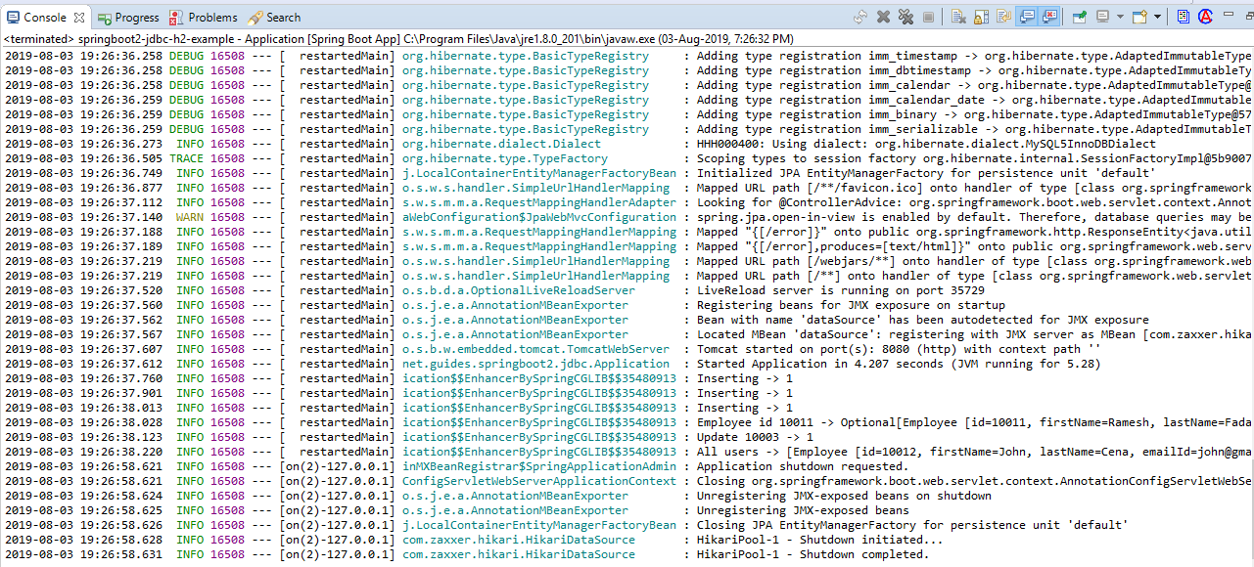
Conclusion
In this tutorial, we have learned how to create a Spring boot application that connects to a database using Spring JDBC. We will build an application using Spring’s JdbcTemplate to access data stored in a relational database.

